### SMOKE DETECTION WITH FIRE PREVENTION USING CISCO PACKET TRACER

BATCH 6

NAME A.SINDHU PRIYA 18071A04C4

NAME J.SREEKAR 18071A04E9

NAME K.PRUTHVINATH 18071A04F6

NAME SHAIK FAYAZUDDIN 18071A04H3



**Department of Electronics & Communication Engineering**

**VALLURUPALLI NAGESWARA RAO VIGNANA JYOTHI INSTITUTE OF ENGINEERING AND TECHNOLOGY**

An Autonomous Institute

(Approved by AICTE, New Delhi, Govt. of TS and Affiliated to JNTUH)

Accredited by NBA and NAAC with A++ Grade

Vignana Jyothi Nagar, Bachupally, Nizampet (S.O), Hyderabad-500090,

Telangana, India.

1. **INTRODUCTION**

Environment has been deeply harmed by humans since a great deal of time, but with the technological advancements we can try and heal it. Detection of fire in homes is necessary to avoid destruction of property due to fire accidents both natural and induced.

Detection of fire can prove to be very important as it could mean the difference between life and death. Fires can occur from anywhere and at any point of time, hence the presence of Fire Alarm System helps in keeping your family safe. An automatic smoke detecting system will notify the individual as well as take necessary actions in the home to prevent the fire from spreading. It will help in detecting fire or smoke at an early stage and can help in saving lives. In our proposed system we are making use of Internet of Things as the technology and though a smoke sensor we will notify various home equipment to take appropriate actions to stop the fire from spreading.

The system is beneficial as it not just buzzes an alarm but also alerts the home appliances to do as they are needed.

Scope

Our model, consisting of the smoke sensor has been conditioned to a limit of 0.5, which implies that if the smoke level detected by the sensor reaches more than the level set, appropriate actions will be taken. This can be changes according to the desire of the individual, situation, or surroundings.

Furthermore, there are a limited set of appliances that are prompted by the smoke sensor, which can be changed. Windows, doors, and garage doors open when the smoke level exceeds the given level. The sprinklers too start spraying water to prevent the spread of fire in the household.

**2. WORKING**

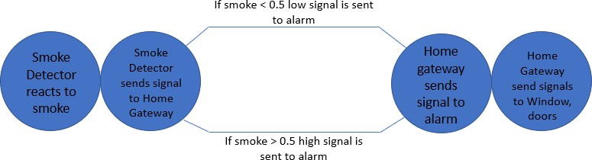

Our Smoke detection and fire prevention project was implemented on Cisco- packet tracer for testing. Components used for our project are as follows:

Home Gateway: A router that forwards the data to the server and the control information to the connected devices for alerting purposes and hence allows it to take necessary actions to extinguish the fire.

* Door: Affects Argon, Carbon Monoxide, Carbon Dioxide, Hydrogen, Helium, Methane, Nitrogen, O2, Ozone, Propane, and Smoke. When the door is opened, those gases will decrease to a maximum of 2% in total change. When the door is opened, the rate of transference for Humidity and Temperature is increased by 25%. The rate of transference for gases is increased by 100%
* Smoke Detector: Detects Smoke. Alarm will go off when it detects the environment variable SMOKE at the level of 40%.
* Fire Sprinkler: Raises the water level. Affects Water Level at a rate of 0.1 cm per second. This is connected to the smoke detector.
* Siren: Makes a loud emergency noise when activated. It is activated when certain conditions are encountered.
* Garage Door: Affects Argon, Carbon Monoxide, Carbon Dioxide, Hydrogen, Helium, Methane, Nitrogen, O2, Ozone, Propane, and Smoke. When the door is opened, those gases will decrease to a maximum of 4% in total change. When the door is opened, the rate of transference for Humidity and Temperature is increased by 50%. The rate of transference for gases is increased by 100%.
* Smartphone: This is the user interface that allows the user to know that a fire occurred at their place with the help of the application running on their smartphone and the amount of smoke generated and hence take necessary steps.
* Window: A window is an opening in a wall, door, roof or vehicle that allows the passage of light, sound, and sometimes air.

1. **PROCEDURE**

* We have used home gateway which connects LAN to WAN
* All the IP addresses are addressed dynamically. For this we are using DHCP which automatically allocates the IP address
* We are using home gateway. Each and every device is connected to it wirelessly
* We have set a certain threshold for the smoke detector. If it crosses that threshold then all the components (Siren, fire sprinkler etc.) will get activated
* The threshold value for smoke detector is 0.5, If it crosses that level then siren, fire sprinkler, door will be locked, window, garage door will be opened.
* This decreases the level of smoke intensity

**4. LAYOUT**

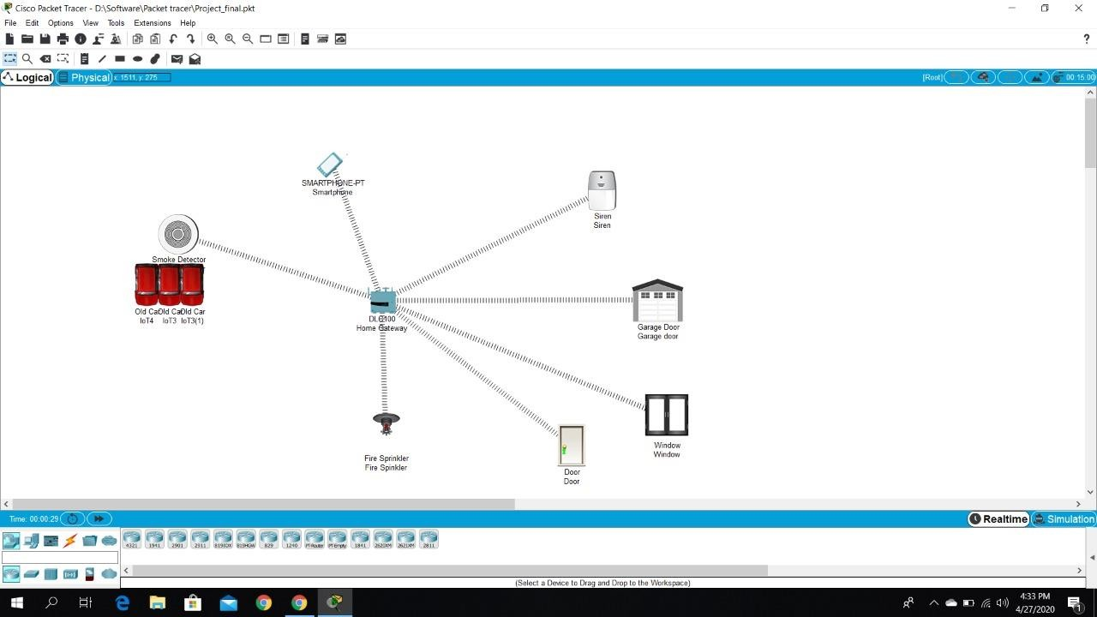

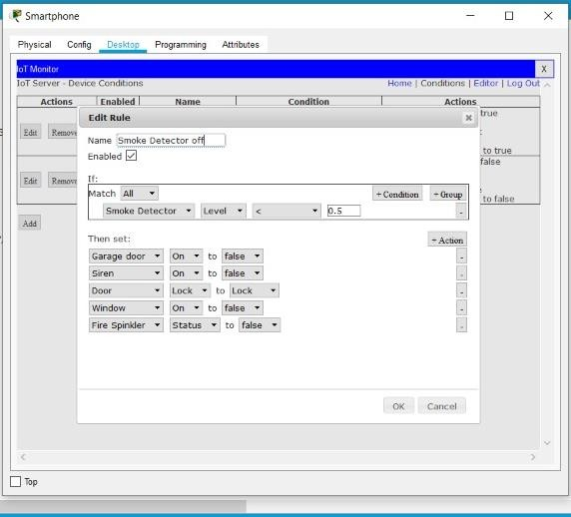

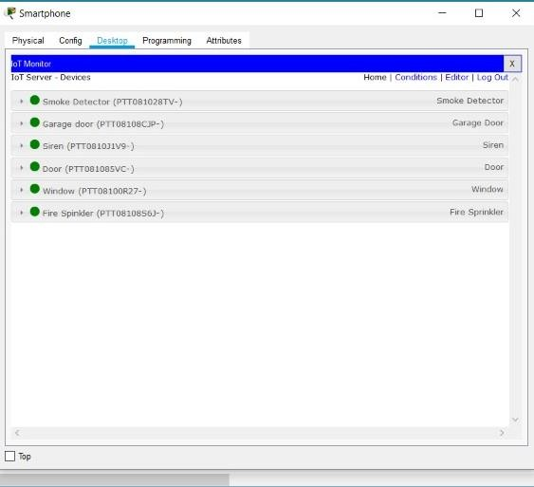

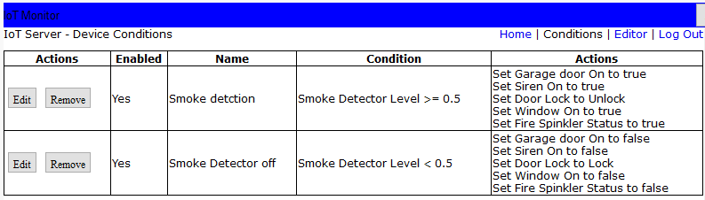

**5. OUTPUT (OUTPUT SCREENSHOTS)**

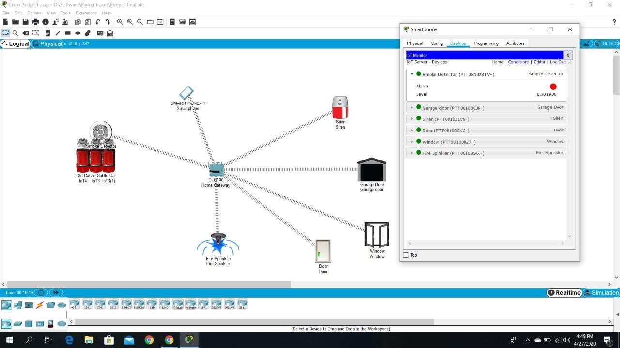Screenshots of the outputs obtained